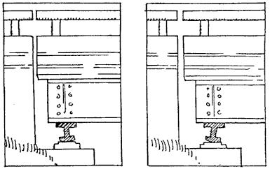
Temperature, Heat and Expansion W.S.

1. Refer to the following information for the next two questions.

Long steel bridges often have one end fixed while the other end rests on rockers, as shown.

Each sketch shows the bridge at a different season of the year.
a. Mark the sketches winter (W) or summer (S). Be prepared to defend your answer.

left sketch

summer | winter

right sketch

summer | winter

- Refer to the following information for the next question. The weight hangs above the floor from the copper wire.
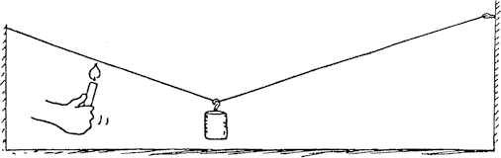

  - When a candle is moved along the wire and heats it, what happens to the height of the weight above the floor? Why?

- Refer to the following information for the next question.
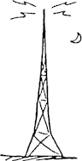
A steel television broadcasting tower is taller in the daytime than it is in the cooler nighttime. This is because steel expands (or contracts) about 1 part in 100,000 for each degree Celsius change. By this we mean that a piece of steel 100,000 units long will be 100,001 units long when its temperature increases by 1 Cº.

a. What is the change in height for a 600-m steel tower when its temperature changes 30 Cº from day to night?

- Refer to the following information for the next question.
A common saying is "water seeks its own level," and usually it does. Here we see a container of water that is cooled on the left and warmed on the right. Consider the effect of temperature on density.
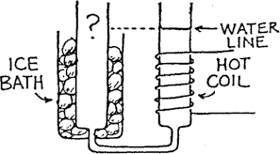

  - Compared to the water level in the right tube, the water level in the left tube is

slightly higher | slightly lower | the same

5. Refer to the following information for the next question.

The levels of water at 0ºC and 1ºC are shown below in the first two flasks. At these temperatures there is microscopic slush in the water. There is slightly more slush at 0ºC than at 1ºC. As the water is heated, some of the slush collapses as it melts, and the level of the water falls in the tube. That's why the level of water is slightly lower in the 1ºC-tube.

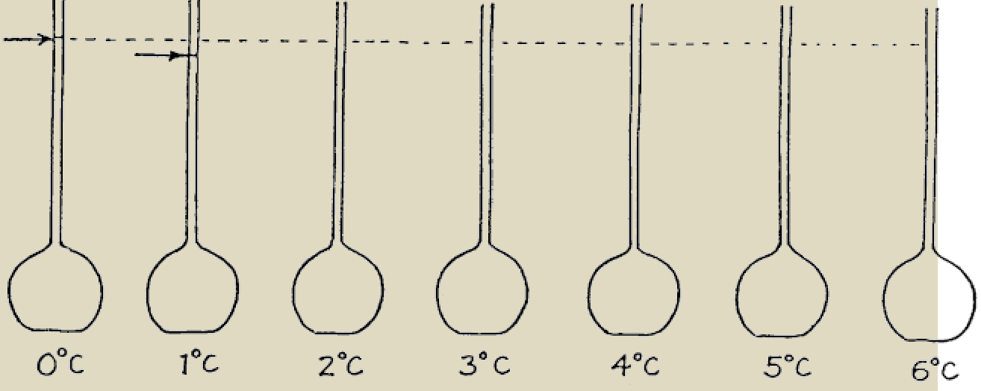
- Discuss and make rough estimates regarding the appropriate levels of water at the other temperatures shown.

- Describe your conclusion and explain what is important about the level when the water reaches 4ºC.
6. Refer to the following information for the next two questions: The diagram below shows an ice-covered pond.
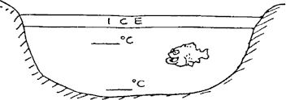

- Mark the probable temperatures of water at the top and bottom of the pond.

Top:

Bottom:
b.
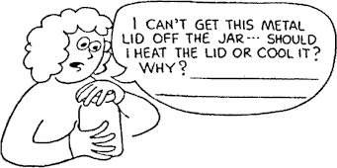

heat the lid | cool the lid

c.

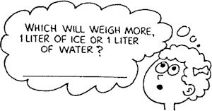

liter of ice | liter of water

7. Refer to the following information for the next two questions.

Suppose you apply a flame and heat one liter of water, raising its temperature 10ºC.

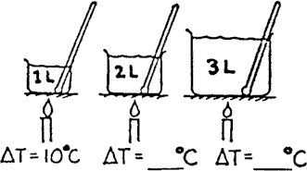
  - How much will the temperature rise if you transfer the same heat energy to 2 liters?

  - How much will the temperature rise if you transfer the same heat energy to 3 liters?

8. Refer to the following information for the next three questions.

A thermometer is in a container half-filled with 20ºC water.

- When an equal volume of 20ºC water is added, the temperature of the mixture is:

10ºC | 20ºC | 40ºC

- When instead an equal volume of 40ºC water is added, the temperature of the mixture will be

20ºC | 30ºC | 40ºC

- When instead a small amount of 40ºC water is added, the temperature of the mixture will be
9. Refer to the following information for the next four questions.

A red-hot piece of iron is put into a bucket of cool water. Mark the following statements true or false.

20ºC
between 20ºC and 30ºC
30ºC
more than 30ºC

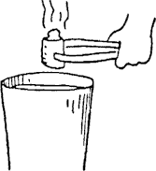
You may ignore any heat transferred to the bucket.

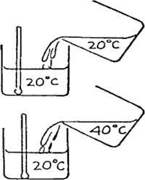

- The decrease in iron temperature equals the increase in the water temperature.

True | False

- The quantity of heat lost by the iron equals the quantity of heat gained by the water.

True | False

- The iron and water both will reach the same temperature.

True | False

The final temperature of the iron and water is halfway between the initial temperatures of each.

True | False

10. Refer to the following information for the next two questions.

Complete the following table of temperatures for the freezing point and boiling point of water.

scale: | Celsius | Fahrenheit | Kelvin

Freezing:

Boiling:

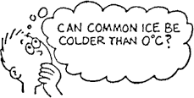

Refer to the following information for the next four questions:

FORMULAS: | ΔL = αLΔT | ΔA = (2α)AΔT | ΔV = βVΔT
 | linear expansion | area expansion | volume expansion
- Selena has a fire in her fireplace to warm her 20°C apartment. She realizes that she has accidentally left the iron poker (α_{iron} = 12 x 10⁻⁶ C°⁻¹) in the fire. How hot is the fire if the 0.60- meter poker lengthens 0.30 cm?

- As he rides the train to work on a -4°C winter day, Mr. Trump notices that he can hear the click of the train going over the spaces between the rails. Six months later, on a 30°C summer day, the rails are pushed together and he hears no clicks. If the rails are 5 meters long when the temperature is 30°C, how large a gap is left between the steel rails (α_{steel} = 12 x 10⁻⁶ C°⁻¹) on the cold winter day?

- A popular winter activity of many college students is "traying," or sliding down a snow-covered hill on a tray borrowed from the dining hall. If Joanne removes a 0.35 meter x 0.65 meter aluminum tray (α_{aluminum} = 24 x 10⁻⁶ C°⁻¹) from the 20°C dining hall to go traying outside in the brisk -8°C winter air, how much will the tray shrink when it is taken outside?

- Most bridges contain interlocking steel grates (α_{steel} = 12 x 10⁻⁶ ºC⁻¹) that allow the bridge to expand and contract with the changes in temperature. The Golden Gate Bridge in San Francisco is about 1350 meters long.
  - The seasonal temperature variation in San Francisco ranges from about 0°C to 30°C. How much will the bridge expand between these two extremes?

  - What percent of the length of a subcompact automobile, 2.5 meters, does this gap represent?

- Just before midnight, when the air temperature of 10.0°C, Karl stops and fills the 0.0600 m³ gas tank in his car. At noon the next day, when the temperature has risen to 32°C, Karl finds a puddle of gasoline (β_{gas} = 3 x 10⁻⁴ C°⁻¹) beneath his car.
  - What happened?

  - How much gasoline spilled out of Karl's car? (assume that there was virtually no change in the volume of his tank)

ΣQ_{lost} + ΣQ_{gained} = 0 where Q = mcΔT and ΔT = T_{f} - T_{o}

Notes: this formula for heat lost or heat gained only applies when there is no change in phase. In the English system, heat is measured in calories where 4.186 J = 1 calorie. A calorie is defined as the amount of heat required to raise one gram of water 1 Cº. A calorie in a dietbook is a kilocalorie, or 1000 calories, which equals 4186 J.

c_{water} = 4186 J/kgC° | c_{glass} = 840 J/kgC° | c_{silver} = 240 J/kgC° | c_{human} _{body} = 3470 J/kgC°

- Hypothermia can occur if the body temperature drops to 35.0°C, although people have been known to survive much lower temperatures. On January 19, 1985, 2-year-old Michael Trode was found in the snow near his Milwaukee home with a body temperature of 16.0°C. If Michael's mass was 10.0 kg, how much heat did his body lose, assuming his normal body temperature was 37.0°C? (Happily, Michael survived!) Show work.

- Peter is heating water on the stove to boil eggs for a picnic. How much heat is required to raise the temperature of his 10.0 kg pot of water from 20.0°C to 100.°C? (Show work.)

- Emily is testing her baby's bath water and finds that it is too cold, so she adds some hot water from a kettle on the stove. If Emily adds 2.00 kg of water at 80.0°C to 20.0 kg of bath water at 27.0°C, what is the final temperature of the bath water? (Show work)

- Nils is emptying the dishwasher. He removes a 0.200 kg glass that has a temperature of 30.0°C. Into it he pours 0.100 kg of diet soda (mostly water) which comes out of the refrigerator with a temperature of 5.00°C. Assuming no external heat loss, what will be the final equilibrium temperature of the glass of diet soda (no ice was added)? (Show work)

- Gwyn's insulated bowl is filled with 0.175 kg of 60.0°C soup (mostly water) that she stirs with a 20.0°C silver spoon of mass 0.0400 kg. the spoon slips out of her hand and slides into the soup. What equilibrium temperature will be reached if the spoon is allowed to remain in the soup and no heat is lost to the outside air? (For simplicity, assume that the temperature of the bowl does not change.)

- On a hot afternoon you may hear creaking noises in a house’s attic. Creaking may also be heard at night. What causes this?

- Why are concrete highways and driveways poured in sections rather than in one long strip?

Sidewalks are sometimes poured in strips, but groove joints are made. What does this do?

- When cold water is run on a hot plate or a hot liquid is poured in a glass, the plate or glass often cracks. Why?

- When one drinking glass is stuck inside another an old trick to unstick them is to put water in one of them and run water at a different temperature over the outside of the other. Which water should be hot and which should be cold?

- When a thermometer is inserted into hot water, the mercury or alcohol is sometimes observed to fall slightly before it rises. Why?

- Most substances expand with increasing temperature. Explain this expansion in terms of molecular theory.

- Water has unique thermal expansion properties. As the temperature increases between 0⁰C and 4⁰C, the volume decreases. Compare the two graphs below and explain the differences.
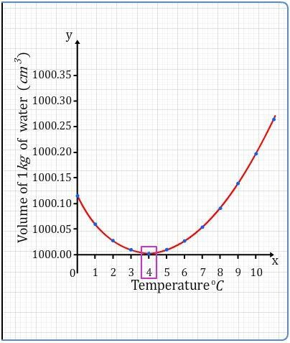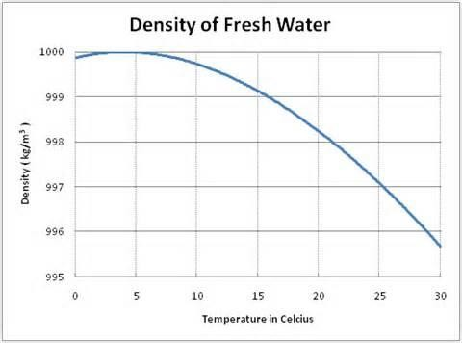
Explain why the volume of water increases from 4⁰C to 0⁰C.

- In light of #23, would water be a good liquid for a liquid-in-glass thermometer? How would such a thermometer behave near the ice point?

- Why are thermal expansion properties an important consideration for materials used in tooth fillings?

- What is the most commonly used temperature scale in the world?
- Which unit is larger, a degree Fahrenheit or a Celsius, and by how much?
- How do you know that the pastry and vegetables of a quiche are in fact at the same temperature?
- Why is a hot-water bottle so delightful on cold winter’s nights?

- Why do you not burn your hand inside an oven at 300⁰C?
- But why do you bun it on a metal tray taken from that same over?
- In Fiji, the firewalkers perform on pumice after going into a cataleptic trance. Why is pumice pumice especially suitable?

- In 1984, a reporter for a San Francisco radio station attended a weekend fire-walking workshop at the invitation of a "psychic". The psychic claimed that no one had ever been hurt at the workshops, but when the reporter walked across the nearly three-meter-long bed of coals, she suffered first- and second- degree burns. Her tape recording, including her screams during the walk, was run on the station's news program the next Monday morning.

Also in 1984, a reporter for Rolling Stone magazine published an account of workshops given by a California "guru" who taught how "mind-control" can eliminate the burns from walking over hot coals if the participants strongly willed themselves to the task. Indeed, most participants escaped burns when they were emotionally revved up and then tested with the coals. Afterward, one claimed that if he had full control over his mind, he could even "survive a direct nuclear blast."

Fortunately, he was not around two nights later when a young woman with brain and spine injuries hobbled over the coals with two canes. She apparently believed the guru's spiel about how "thinking the right thoughts" can prevent burns from the coals. The Rolling Stone reporter noted that the average time of the participants on the coals was 1.5 seconds but that the young woman stalled there for 7 seconds when she collapsed from the pain. Before she fell onto the coals, she was grabbed and whisked away from the scene. She spent 12 days in a hospital with severe burns to her feet. Explain why? (Hint: It is not because she had the wrong thoughts).

- If you ever attend a firewalker’s performance, you can say to him/her, ‘I see you walking on coals which are at a temperature of over 1000⁰C; would you please now stand for a couple of seconds on this portable electric hot-plate which is a 300⁰C (and which by a
strange coincidence I just happen to have with me)?’ What would happen to the firewalker?

- REVIEW: The inverted drinking glass filled with air is placed mouth downward in water. As it is pushed deeper, the air is compressed.

  - How deep must the glass be pushed in order that the air be compressed to half its original
volume?

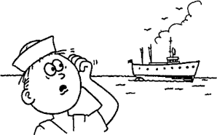
At this depth, how will the buoyant force on the submerged glass compare to when it was submerged at the surface?

- Review:

Compared to an empty ship, will a ship loaded with a cargo of styrofoam float lower or higher in water?

- Review:
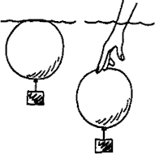

Consider an air-filled balloon weighted so that it is on the verge of sinking ... that is, its overall density just equals that of water. Now if you push it beneath the surface, it will .

- sink
- return to the surface
- stay at the depth to which it is pushed

